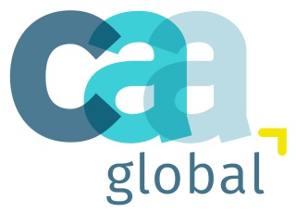 | Certified Actuarial Analyst  Exam entry form - Module 5  19 May 2021

Please complete this form and return it with payment to:
CAA administration team, C/O The Institute and Faculty of Actuaries, 1st Floor, Park Central, 40/41 Park End Street, Oxford, OX1 1JD, UK. Tel: +44 (0)1865 268266 Email: enquiries@caa-global.org

THIS FORM IS FOR PAYMENT IN US DOLLARS ONLY

This form and payment must be received by the CAA Administration Team by 03 May 2021
(17.00 UK time)

Personal details
Name (BLOCK CAPITALS) |  |  |  |  | ARN
Company name
See next pages for exam dates and payment details
Payment must be sent with the application form. Failure to do so may result in candidates not obtaining a place.
In submitting this form I confirm I have read and understood the examination regulations and notes issued.
(Please tick box to agree to the above statement).

Signature |  |  |  | Date

Exam date – 19 May 2021
The Module 5 exam consists of 1 three hour paper, It is an online exam and will be taken via a Virtual learning Environment (VLE).

Information and a link to the exam platform will be sent via email one week before the exam start date.

Online exams: Full fee $414 – Reduced fee $249

Payment details: We do not invoice examination fees.
 | Bank transfer | USD$ |  | Please enter the total amount of Bank transfer.  A remittance advice MUST accompany this form as proof of your payment.
Account name |  |  | CAA Global Ltd |  | IBAN | GB96NWBK60730127684989
Account number |  |  | 140/00/27684989 |  | Bank name | National Westminster Bank PLC
 |  |  |  |  | Bank address | Holborn Circus Branch  PO Box No 204  No.1 Hatton Garden  London, EC19 1DU
SWIFT |  |  | NWBKGB2L
Please enter Bank transfer payment reference: Exam name and then candidate’s ARN, e.g. SMITH 9134567 CAA

To pay by Visa, Amex or MasterCard
If you wish to pay by card please login to your online account to pay for and then schedule your exam.

DO NOT return this form to pay by card.

If you experience any problems with the online booking system, please telephone the CAA administration Team on +44 (0)1865 268266, and they will be able to help you in process your booking.

